ASSIGNMENT 2

**DOMAIN:** IOT

**TEAM ID:** PNT2022TMID29677

**TEAM MEMBERS:**

* Keerthivasan P - 513119106043
* Jeeva R - 513119106033
* Abhishek R - 513119106004
* Kesavaraja K – 513119106044

**QUESTION:**

Build a python code, assume u get temperature and humidity values (generated with random functions to a variable) and write a condition to continuously detect alarm in case of high temperature

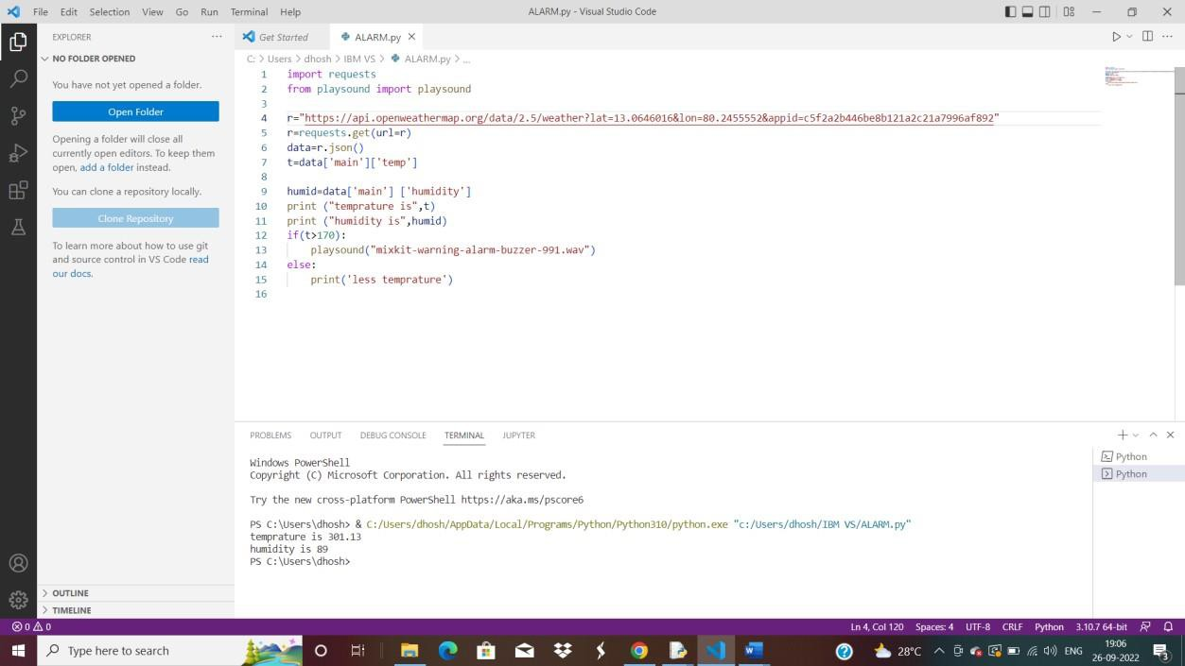

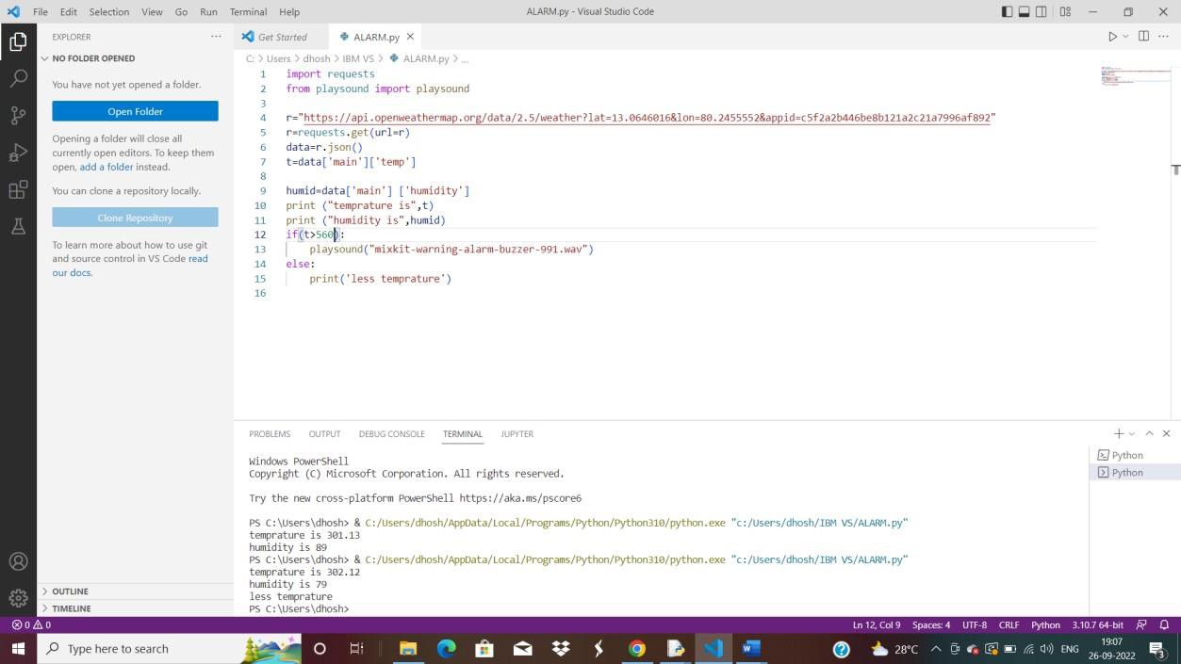

**CODING:**

import requests

from playsound import playsound

r="https://api.openweathermap.org/data/2.5/weather?lat=13.0646016&lon=80.24555 52&appid=c5f2a2b446be8b121a2c21a7996af892"

r=requests.get(url=r) data=r.json() t=data['main']['temp']

humid=data['main'] ['humidity'] print ("temprature is",t) print ("humidity is",humid) if(t>170):

playsound("mixkit-warning-alarm-buzzer-991.wav") else:

print('less temprature')